**DECORATOR PATTERN**

**Problem Statement:**  CoffeeShop Starbucks plans for their ordering system. They are new sensation. Their first attempt for making their Ordering System.

Let’s have a look at their structure:

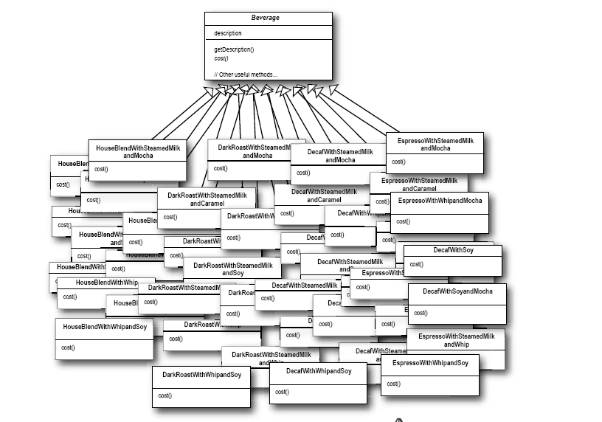

The above structure has a *Beverage*  abstract superclass, with the description field and getDescription() for returning same field. The abstract method *cost()*  is implemented by each individual classes.